Group 5 – Software Engineering Project-Property Tycoon System Level Testing
Test Date: 18/03/2025
Test Environment: PC
Tester: Duncan Law
Testing Build Version:Build.16.03.2025
Execution Mode: Running from Built Executable
Test ID | Description | Input | Expected Outcome | Actual Outcome | Screenshort | Pass/Fail | What Next? | Notes
1 | Game Initialization | Start a new game with 2 human players and 1 AI player | Game should initialize with correct player money (£1,500 each), board setup, and game pieces ,load data from excel file | Cmd output shows game has been Initializat with correct way | 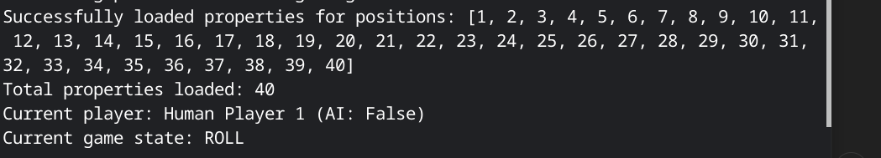 | Pass | No action needed | Test bank limit is £50,000
2 | Dice Rolling and Movement | Click "Roll" button during player turn | Dice animation should display random values 1-6, player token should move the correct number of spaces | dice animation is working and stop in a few second | 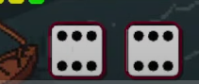 | Pass | No action needed | Check double rolls logic
3 | Player Passing GO | Move player across GO space | Player should receive £200, lap counter should increment | Player should receive £200,and able to buy property after passing go on the first time |  | Pass | No action needed
4 | Property Purchase | Land on unowned property, click "Buy" button | Player money should decrease by property price, property should show ownership | show ownership on the player card with color box | 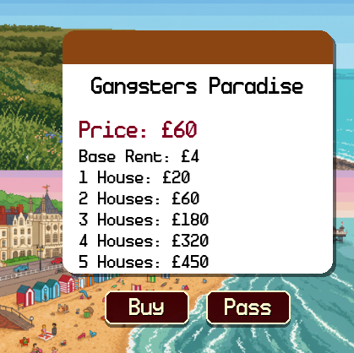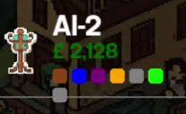 | Pass | No action needed | Test with different property types
5 | Rent Payment | Land on property owned by another player | Correct rent should be calculated and transferred from landing player to owner |  |  | Pass | No action needed | Test different rent scenarios
6 | Auction System | Decline to purchase property when landing on it | Auction interface should appear, all players should be able to bid | yes ,works ,but not for player in jail |  | Pass | No action needed | Test AI bidding behavior
7 | Card Drawing | Land on "Pot Luck" or "Opportunity Knocks" spaces | A card should be drawn and its effect applied to the player |  | 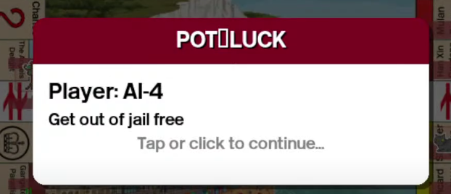 | Fail | problem should be in | Check all card types
8 | Jail Mechanics | Roll three consecutive doubles or land on "Go to Jail" | Player should move to jail, miss turns until conditions met | working ,player position move to jail |  | Pass | No action needed | Test all jail escape options
9 | Free Parking | Land on Free Parking space | Player should collect accumulated fine money (if house rule enabled) | working ,the total amound of free parking space has been show on ui | 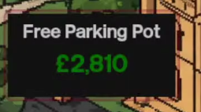 | Pass | No action needed | Optional house rule
10 | House Building | Select a property from a complete set, click "Build House" | House should be added to property, rent values should increase | House added and showed on ui and the board | 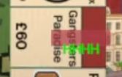 | Pass | No action needed | Test after first lap
11 | Bankruptcy Handling | Force player to pay more money than they have | Player should go bankrupt, assets transferred to bank | player marked as bankrupt |  | Pass | No action needed | fixed:
12 | AI Player Turn Processing | Wait for AI player turn | AI should make decisions based on difficulty level | works | 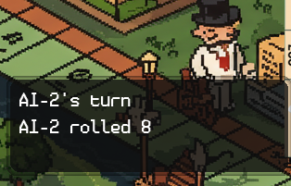 | Pass | No action needed | Test both easy and hard difficulty
13 | Game End Condition | Play until only one player remains solvent | Game should end and declare winner | show end game screen | 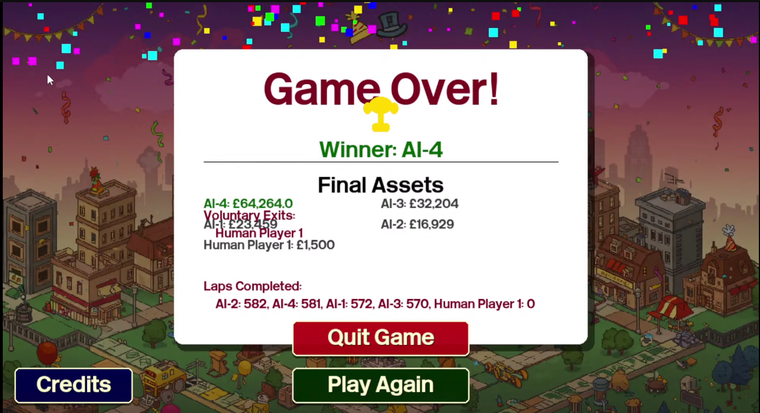 | Pass | No action needed | Check winner calculation
14 | Time Limit (Abridged Game) | Play abridged game mode for set time | Games should end after time expires | show end game screen |  | Pass | No action needed | 180mix max

